Kushal Kale

1. 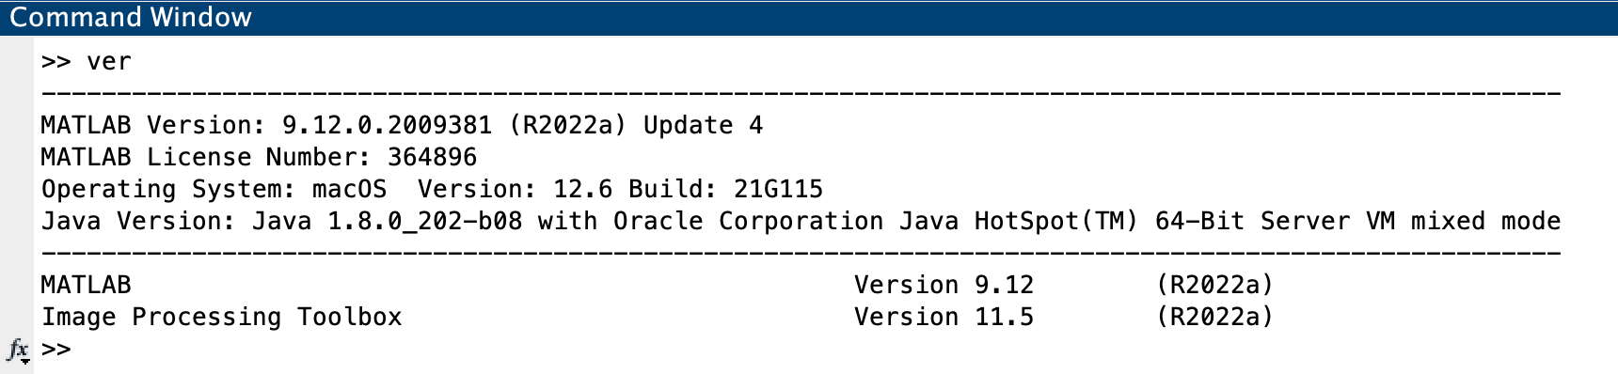
2. Firstly, I compared the R, G and B channels along with the rgb2gray() function. Out of these, the red channel provided the best contrast between the apples and the leaves. So, I chose that one for further processing. Similarly, I chose the V channel from HSV to process further. Then I tried histeq and adapthisteq on all the chosen images and the following are the results.

| Histeq on R | Histeq on V |
| --- | --- |
| Ahisteq on R | Ahisteq on V |

According to me, using the adaptive histogram equalization on the V channel has given the best results.

1. a) 2022:09:06 19:05:40

b) FNumber: 6.3000, Aperture: 5.3750

c) 3200

d) ComponentsConfiguration: YCbCr and ColorSpace: sRGB

e) Flash fired

f) The focal length is 51. The EXIF data of the image does not tell whether the image was focused automatically or manually. The SubjectDistance EXIF tag is not recorded in the given image and so we can not directly get the distance where the image is focused. But it can be roughly calculated using the focal length and the resolution of the focal plane.

1. The effect where we have difficulties naming the actual color of text when that text is used to spell the name of a different color is called the Stroop Effect.  
   Mrs. Kinsman’s photo demonstrates the Stroop Effect as her top has names of colors printed on it but the actual color of the text used does not match the name of the color printed by the text.

It complicates the homework because suppose we extract the green channel from the image, then we expect the color green to be bright. But the color green is printed with the text BLUE and so that appears brighter which causes confusion.

1. 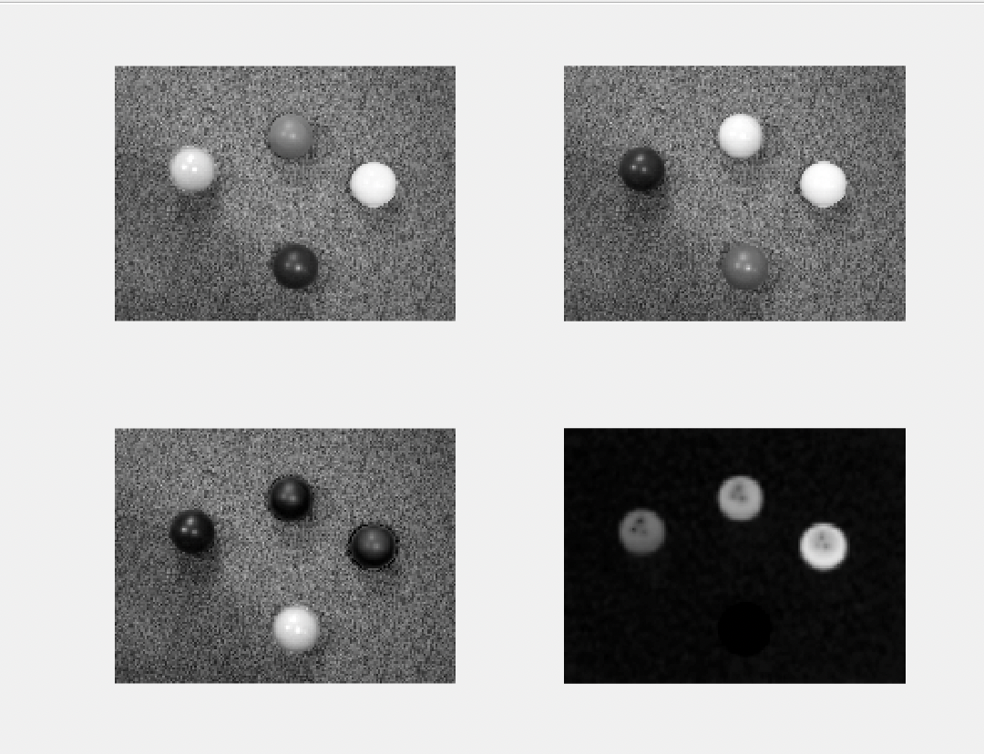  
     
   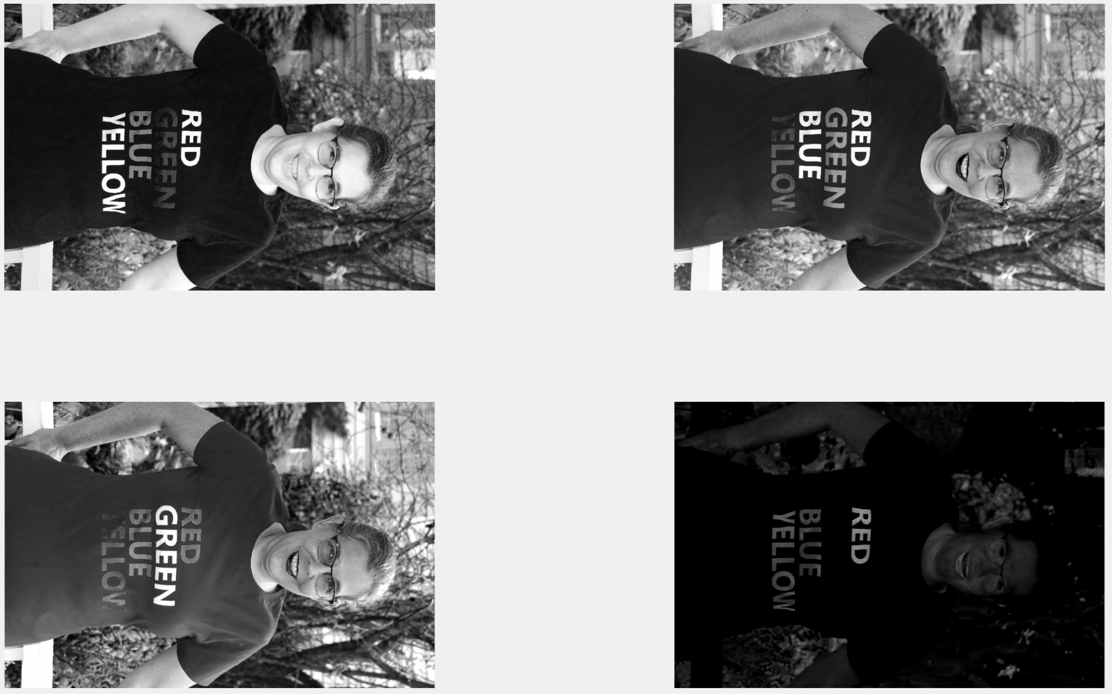
2. I understood how color spaces can be useful in image analysis. Specifically how HSV values can give us even more ways to process the images to get the best and desired results.

I did try imadjust on separate channels but that does not give us the desired results because imadjust just stretches out the low and high values in the image to increase the contrast. Histogram equalization does a better job.

I also learned about the method imfinfo(). It gives us a lot of metadata about the image along with all the EXIF data of the photo. This EXIF data can also prove to be useful in the analysis of the images if the use case demands.

I was surprised by the consequence the Stroop Effect had on my ability to comprehend which color I am thinking about. It was confusing to me while trying to do analysis on Mrs. Kinsman’s image because after extracting a particular channel I was expecting that particular color to be bright in the result but my brain went to the text and not the actual color (despite trying hard to focus on the actual color and not the text).  
Extracting yellow pixel values was also a little tricky for me but I eventually figured it out.